Name: ____________________________ Period: 1 3 4 5 7 Date:_____
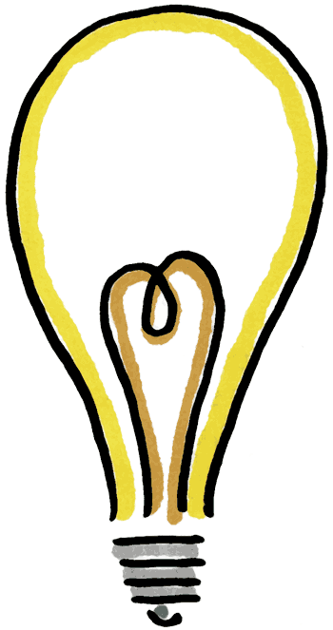
Project Plan
Genius Hour

Title Your Project: Evolution of Technology

Final Essential Question (2 pts.):How has the evolution of
technology affected the human race?

Project Reasoning (2 pts.) : What passion of mine prompted my research?
People use technology every day and I was wondering how that
has affected us as a whole.
Purpose (1 pt.): What will I do with my research? What do I expect to learn from this project? How will I know when I have successfully completed my project? (Long-term Goal)
I will put my research toward my everyday life. If the effect is bad, I will try and learn how to change/modify it. I expect to learn how the evolution has affected the human race and in which ways it has affected us. I will know when I have successfully completed my project when I learn exactly how the evolution of technology has affected the human race.
End Product (1 pt.): What will my finished / end product consist of?
My end project will consist of a weebly website with different tabs showing the research I have done on the different subtopics of my topic.
Plan of action (4 pts.): What will I do? What do I need to find out to reach your goal? What are questions I will need to answer in order to address my essential question? Assign how many days this will take you to complete each question.

1. Break down the essential question into smaller parts to make it easier to get information.
2. Start to find information on each of the topics.
3. Get enough information for each of the topics.
4. Put the information into the final product.
5. Put the final touches on the final product.

Key Words for Research (1 pt.): What phrases, words, and questions do I need to Google to conduct my research?
Phrases such as evolution of technology, effects of evolution, and modern day life with this new technology are some that I need to Google to conduct my research.
Goal for 1st Hour (1 pt.) : What will I try to achieve during my first genius hour? (Short-term Goal)
My goal for the first genius hour is to get the essential questions sheet done.

